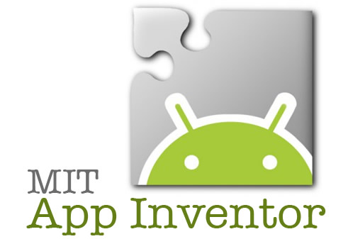**Computer Science & Software Engineering**

**1.2.2 Introducing App Inventor – Commands**

**Name: ____________________**

**Date: ____________________**

**Technology Education Dept.**

**Pittsford Central Schools**

**Procedure:**

In this activity you will investigate commands and functions within MIT APP Inventor. You will choose a specific topic(s) from APP Inventor and will need to present to the class how your topic is coded and utilized on the tablets. Please use screen captures along with written directions explaining how to implement the tool/command within APP Inventor. The goal of this activity is to create a “book” full of tutorials for how to use specific commands from each person in the class. Later in the unit you will create your own App and will be able to resort back to the class book that we create for help.

Your Topic: Sound recorder

Description of how it works...

The sound recorder starts recording when a button is pressed and stops when it is let go. The recording will be stored in tinydb and can be played back by referencing the tag name you gave it.

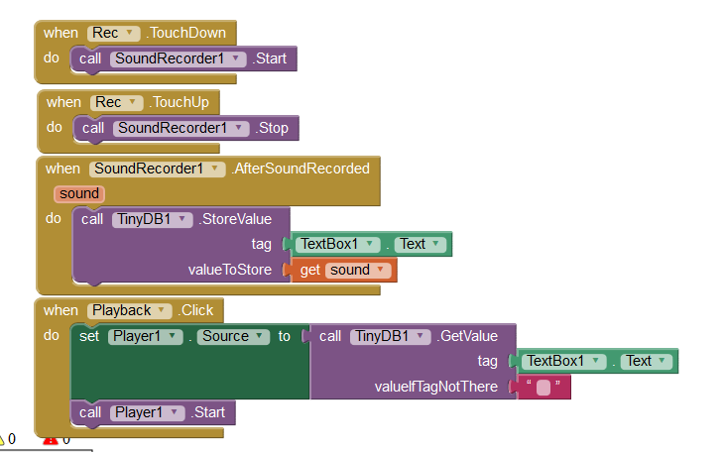In the space below, begin your step by step directions including notes and screen captures for how to implement and use the feature or topic you chose. As part of this assignment you will need to create a brand new App and then create your detailed directions.